DEERWALK INSTITUTE OF TECHNOLOGY

Tribhuvan University

Faculties of Computer Science



**Bachelors of Science in Computer Science and Information Technology**

(B.Sc. CSIT)

Course: Computer Networks (CSC 263)

Class of 2027/Semester: IV

A Lab Report On:

**Designing a network to enable communication between 2 intranets.**

**Submitted by:**

Name: Shaurav Bhandari

Roll No: 1333

**Submitted to:**

Er Rohit Nakarmi

Faculty, Department of Computer Science

# **Lab 2:**

**Objective:**

*Enable communication between 2 intranet topologies with routers.*

**Tools Used:**

* *Cisco Packet Tracer*
* *Router 1941*
* *Switch 2960-24TT*
* *VPCs and Laptops*

**Logical Topology Diagram:**

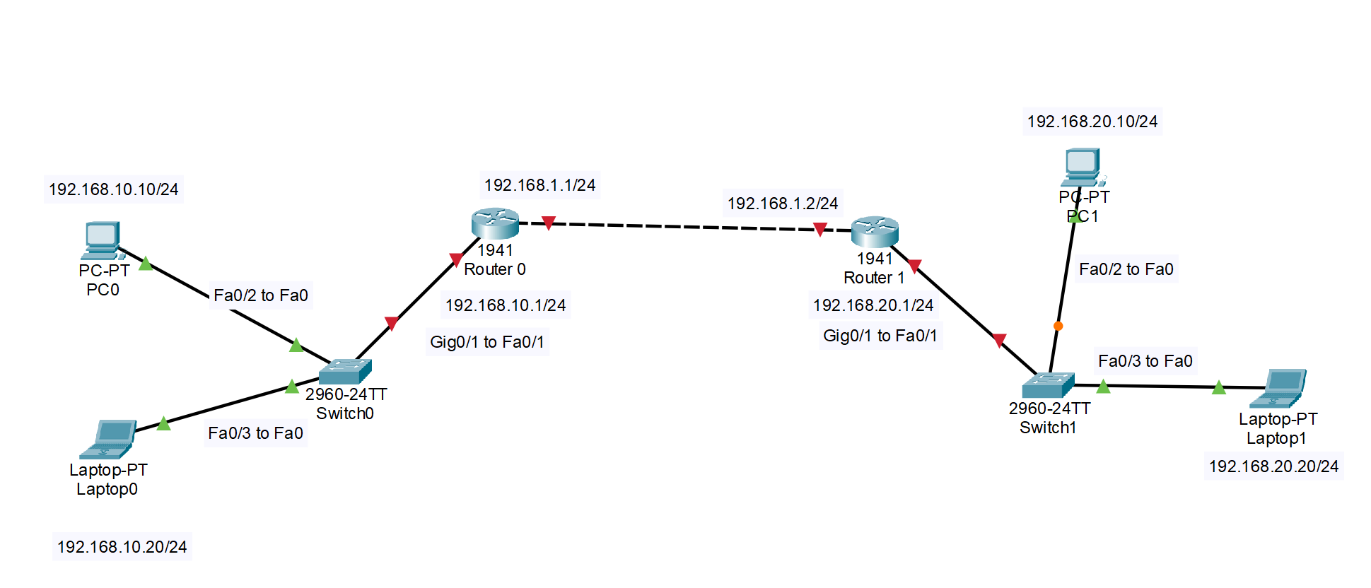

* **Configuration of routers:**
  + **Router 0:**

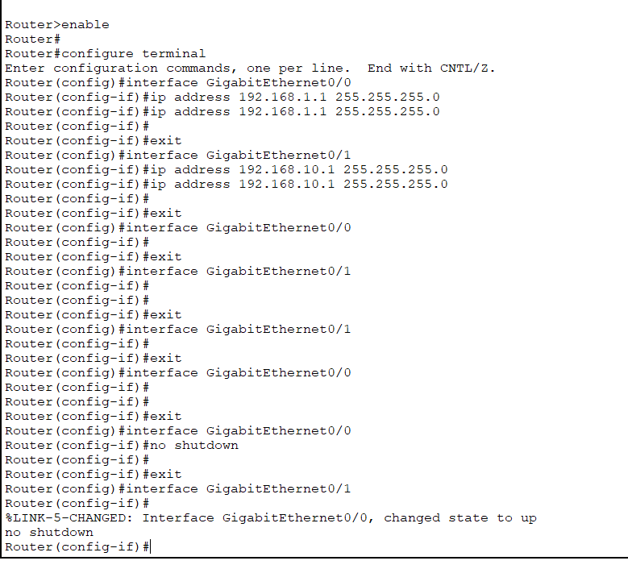

* + **Router 1:**

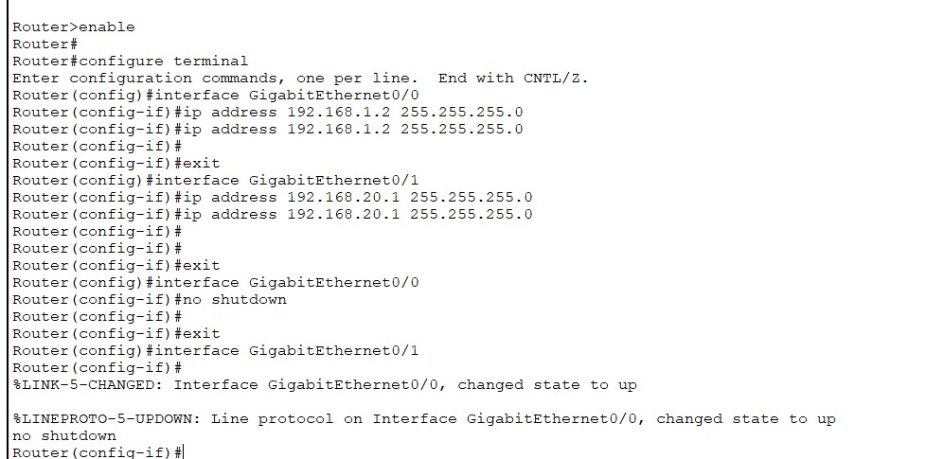

**Configuration of the switches:**

* + **Switch 0:**

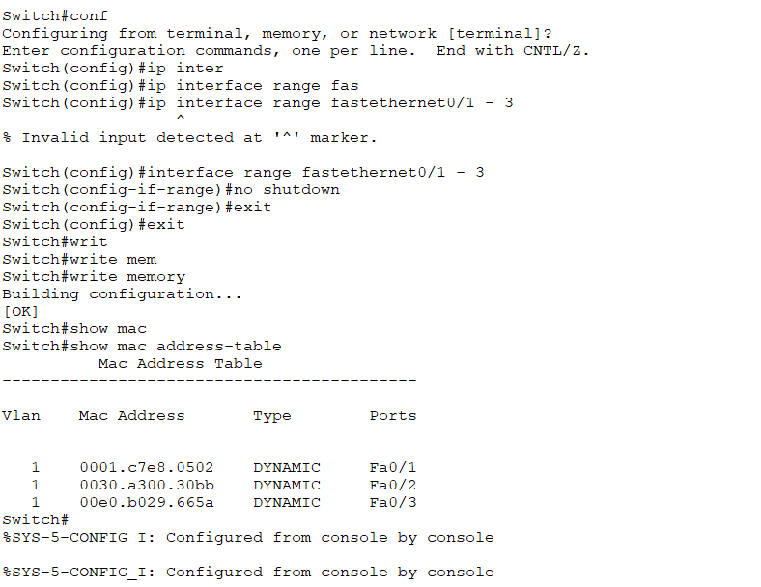

* + **Switch 1:**

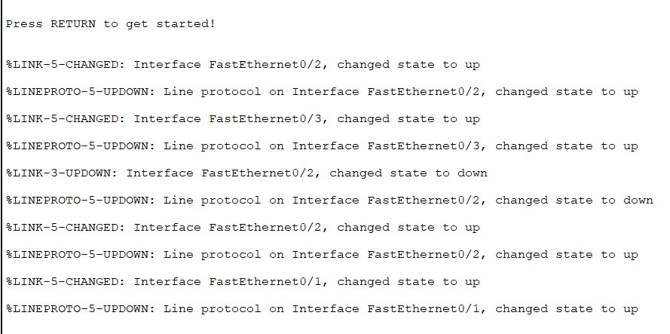

* **Configuration of VPCs and Laptops:**
  + **PC 0:**

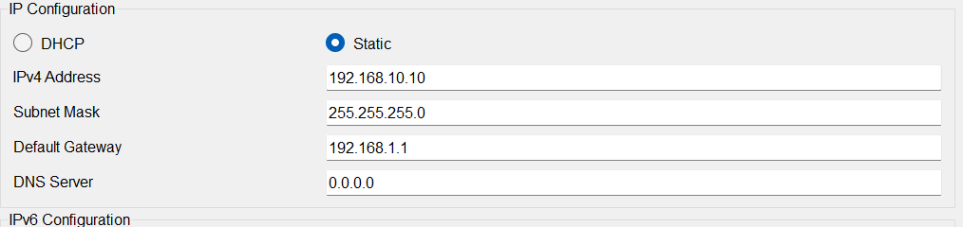

* + **PC 1:**

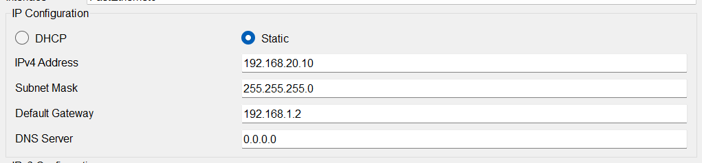

* + **Laptop 0:**

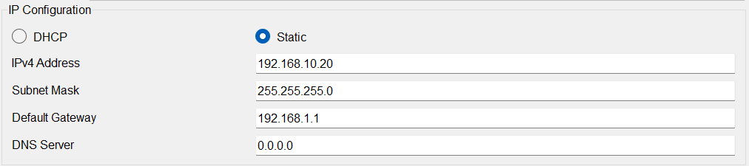

* + **Laptop 1:**

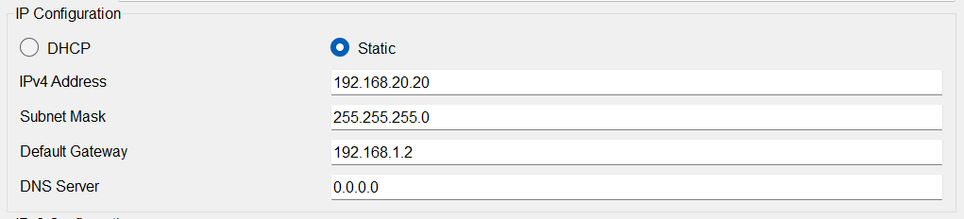

**Communications between PCs:**

* **Communication within the intranet:**





* **Communication between the intranets:**
  + **Ip Routes:**
    - **Router 0:**

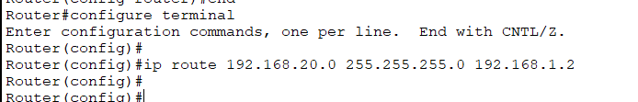

* + - **Router 0:**



* + **Pinging from Devices:**

